Transmission modes

* The way in which data is transmitted from one device to another device is known as **transmission mode**.
* The transmission mode is also known as the communication mode.
* Each communication channel has a direction associated with it, and transmission media provide the direction. Therefore, the transmission mode is also known as a directional mode.
* The transmission mode is defined in the physical layer.

The Transmission mode is divided into three categories:

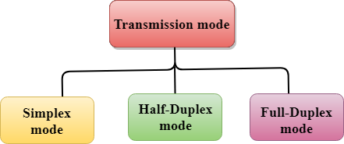

* Simplex mode
* Half-duplex mode
* Full-duplex mode

Simplex mode



* In Simplex mode, the communication is unidirectional, i.e., the data flow in one direction.
* A device can only send the data but cannot receive it or it can receive the data but cannot send the data.
* This transmission mode is not very popular as mainly communications require the two-way exchange of data. The simplex mode is used in the business field as in sales that do not require any corresponding reply.
* The radio station is a simplex channel as it transmits the signal to the listeners but never allows them to transmit back.
* Keyboard and Monitor are the examples of the simplex mode as a keyboard can only accept the data from the user and monitor can only be used to display the data on the screen.
* The main advantage of the simplex mode is that the full capacity of the communication channel can be utilized during transmission.

Advantage of Simplex mode:

* In simplex mode, the station can utilize the entire bandwidth of the communication channel, so that more data can be transmitted at a time.

Disadvantage of Simplex mode:

* Communication is unidirectional, so it has no inter-communication between devices.

Half-Duplex mode

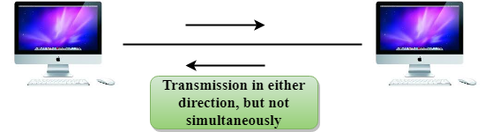

* In a Half-duplex channel, direction can be reversed, i.e., the station can transmit and receive the data as well.
* Messages flow in both the directions, but not at the same time.
* The entire bandwidth of the communication channel is utilized in one direction at a time.
* In half-duplex mode, it is possible to perform the error detection, and if any error occurs, then the receiver requests the sender to retransmit the data.
* A **Walkie-talkie** is an example of the Half-duplex mode. In Walkie-talkie, one party speaks, and another party listens. After a pause, the other speaks and first party listens. Speaking simultaneously will create the distorted sound which cannot be understood.

Advantage of Half-duplex mode:

* In half-duplex mode, both the devices can send and receive the data and also can utilize the entire bandwidth of the communication channel during the transmission of data.

Disadvantage of Half-Duplex mode:

* In half-duplex mode, when one device is sending the data, then another has to wait, this causes the delay in sending the data at the right time.

Full-duplex mode



* In Full duplex mode, the communication is bi-directional, i.e., the data flow in both the directions.
* Both the stations can send and receive the message simultaneously.
* Full-duplex mode has two simplex channels. One channel has traffic moving in one direction, and another channel has traffic flowing in the opposite direction.
* The Full-duplex mode is the fastest mode of communication between devices.
* The most common example of the full-duplex mode is a telephone network. When two people are communicating with each other by a telephone line, both can talk and listen at the same time.

Advantage of Full-duplex mode:

* Both the stations can send and receive the data at the same time.

Disadvantage of Full-duplex mode:

* If there is no dedicated path exists between the devices, then the capacity of the communication channel is divided into two parts.

Differences b/w Simplex, Half-duplex and Full-duplex mode

|  |  |  |  |
| --- | --- | --- | --- |
| **Basis for comparison** | **Simplex mode** | **Half-duplex mode** | **Full-duplex mode** |
| Direction of communication | In simplex mode, the communication is unidirectional. | In half-duplex mode, the communication is bidirectional, but one at a time. | In full-duplex mode, the communication is bidirectional. |
| Send/Receive | A device can only send the data but cannot receive it or it can only receive the data but cannot send it. | Both the devices can send and receive the data, but one at a time. | Both the devices can send and receive the data simultaneously. |
| Performance | The performance of half-duplex mode is better than the simplex mode. | The performance of full-duplex mode is better than the half-duplex mode. | The Full-duplex mode has better performance among simplex and half-duplex mode as it doubles the utilization of the capacity of the communication channel. |
| Example | Examples of Simplex mode are radio, keyboard, and monitor. | Example of half-duplex is Walkie-Talkies. | Example of the Full-duplex mode is a telephone network. |